

**Customer Requirement Specifications (CRS)**

***Inventory Management***

# **Document Information**

|  |  |
| --- | --- |
| Document Name | CRS of Inventory Management for Samuda Chemicals Ltd. |
| Document Author | Kamrun Nahar |
| Document Version | 1.0 |
| Release Date | Mar 13, 2017 |

|  |  |
| --- | --- |
| Review by | Md. Mahfuzur Rahman |
| Review Date | Mar 13, 2017 |
| Approved By | Matiar Rahman |
| Approval Date | Mar 14, 2017 |

Signed on behalf of Signed on behalf of

Samuda Chemicals Ltd. Genweb2 Limited

Name: Name:

Designation: Designation:

Date: Date:

**______________________________ ______________________________**

Signature Signature

# **Document History**

|  |  |  |  |  |  |
| --- | --- | --- | --- | --- | --- |
| A=Added, M=Modified, D=Delete | | | | | |
| **Version No** | **Date** | **Section No** | **A/M/D** | **Description of Change** | **Author** |
| 1.0 | Mar 13, 2017 |  | A | Initial | Kamrun Nahar |
|  |  |  |  |  |  |
|  |  |  |  |  |  |

**Contents**

**A.** **Document Information** 2

**B.** **Document History** 3

**1.0** **Introduction** 5

**1.1 Purpose of CRS** 5

**2.0 Inventory Module Overview** 5

**3.0** **Why Organization Use Inventory Management** 6

**4.0 Functional features of inventory modules are given below** 6

**5.0 Inventory Process** 7

**6.0 Process Flow Description** 7

**6.1 Raise Indent** 7

**6.2 Issue Item Process** 8

**6.3 Issue Return Process** 9

**6.4 Gate Pass In Process** 10

**6.5 Receive Goods Process** 11

**6.6 Receive Return Process** 12

**6.7 Quality Control (QC) Process** 13

**6.8 Material Receive Report (MRR)** 14

**6.9 Goods Delivery Process** 14

**6.10 Gate Pass out Process** 15

**6.11 Inventory Item Transfer Process** 16

**6.12 Physical Inventory Process** 17

**6.13 Item Loan Process** 18

**a) Item Loan (Lending Process)** 18

**b) Item Loan (Borrowing Process)** 20

**7. Appendix** 22

**8. To be Determined** 27

# **Introduction**

# **1.1 Purpose of CRS**

The purposes of this CRS (Customer Requirement Specification) are to clearly identify the customer requirements and provide a detailed document. The customer will review the document and approve/make changes as required. It will also help the review team to validate whether the customer requirements have been fulfilled or not.

# **2.0 Inventory Module Overview**

**Inventory management** is a system for tracking inventory levels, orders, sales and deliveries. It can also be used in the manufacturing industry to create a work order, bill of materials and other production-related documents. Companies use inventory management software to avoid product overstock and outages. It is a tool for organizing inventory data that before was generally stored in hard-copy form or in spreadsheets.

Efficient inventory management should be able to rapidly respond to customer requirements; at the same time should be flexible enough to undertake any corrections when required, and do the so without adversely affecting operational efficiencies. The Inventory Management module offers effective features to minimize warehousing costs and to optimize storage needs in line with the requirements at hand.

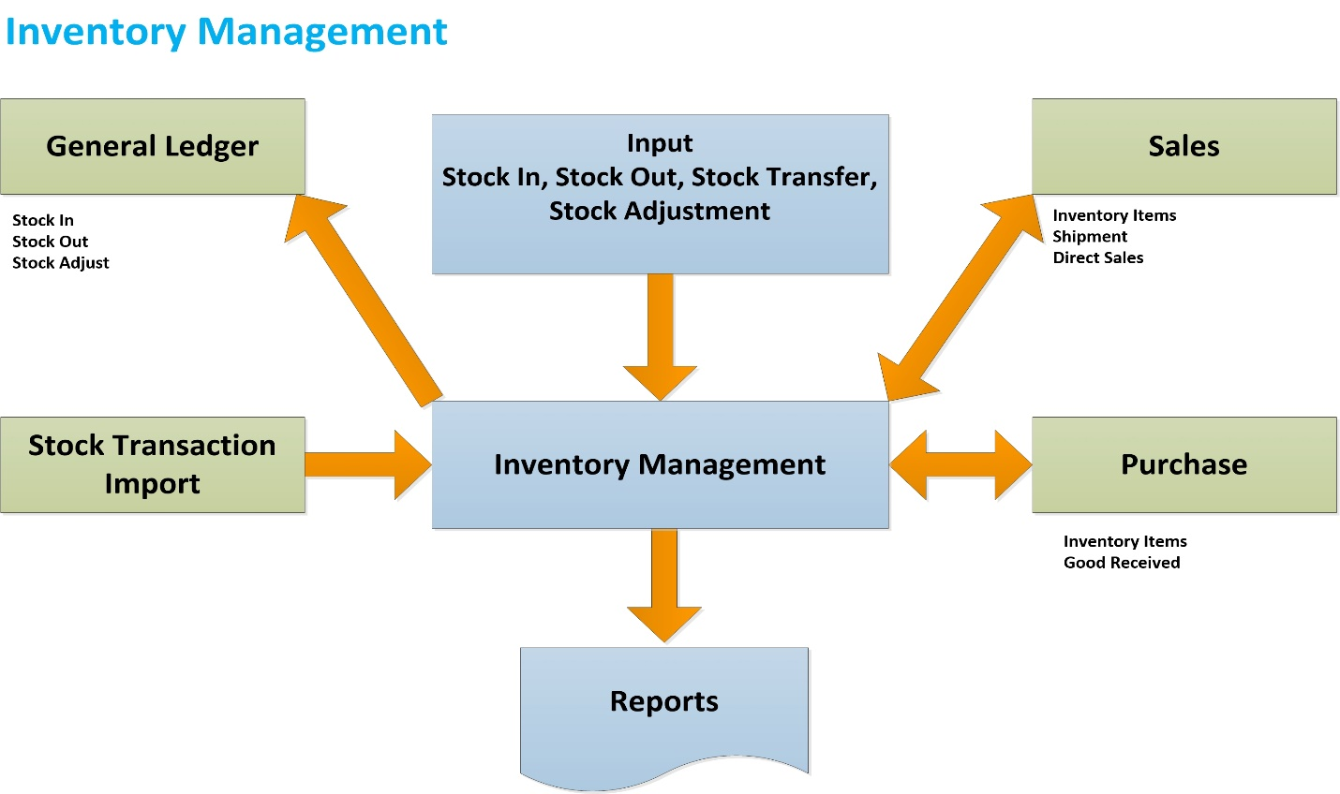

**Fig:** Inventory Management System

# **Why Organization Use Inventory Management**

1. Inventory management is primarily about specifying the shape and percentage of stocked goods.
2. The scope of inventory management concerns the fine lines between replenishment lead time, carrying costs of inventory, asset management, inventory forecasting, inventory valuation, inventory visibility, future inventory price forecasting, physical inventory, available physical space for inventory, quality management, replenishment, returns defective goods and demand forecasting. Balancing these competing requirements leads to optimal inventory levels, which is an on-going process as the business needs shift and react to the wider environment.
3. Management of the inventories, with the primary objective of determining/controlling stock levels within the physical distribution system, functions to balance the need for product availability against the need for minimizing stock holding and handling costs.
4. Inventory management also can help companies improve cash flows. Companies with effective inventory management do not have to spend large capital balances for purchasing enormous amounts of inventory at once. This also saves handling and holding costs.

# **4.0 Functional features of inventory modules are given below**

* Plant Manager or Employee/ Department raises an indent.
* Approval Authority verifies the Indent with necessary information.
* Store Keeper sends all the products according to indent information to Plant Manager or Employer or Department.
* Store Keeper receives goods according to Purchase Order.
* QC Authority checks quality and quantity of goods according to Purchase Order.
* If goods are in good quality and exact quantity then Quality Control (QC) accept goods and update the stock of the goods.
* If goods are not in good condition and not exact quantity, QC Authority returns the rejected goods.
* Store Keeper sends back all rejected goods to Supplier.
* Store Keeper checks all goods and if finds any mismatch then sends the goods to Supplier.
* Transfer Request Authority (Merchandiser / Storekeeper / others) sends request to Approval Authority for item transfer.
* Storekeeper receives request from approval authority for transfer out item from stock.
* Based on approval storekeeper can transfer item from one stock to another stock.
* Storekeeper can issue item to Plant Manager or Employee / Department against indent.
* Plant Manager or Employee / Department can return issued item.
* Storekeeper can adjust the difference item stock in between system and physical.
* Item can be adjusted in case of missing or damaged.

# **5.0 Inventory Process**

* Raise indent process
* Issue item process
* Issue return process
* Gate Pass In Process
* Receive goods process
* Receive return process
* Quality Control(QC) process
* Goods delivery process
* Gate Pass Out Process
* Inventory item transfer process
* Physical inventory process
* Item loan Process

# **6.0 Process Flow Description**

## **6.1 Raise Indent**

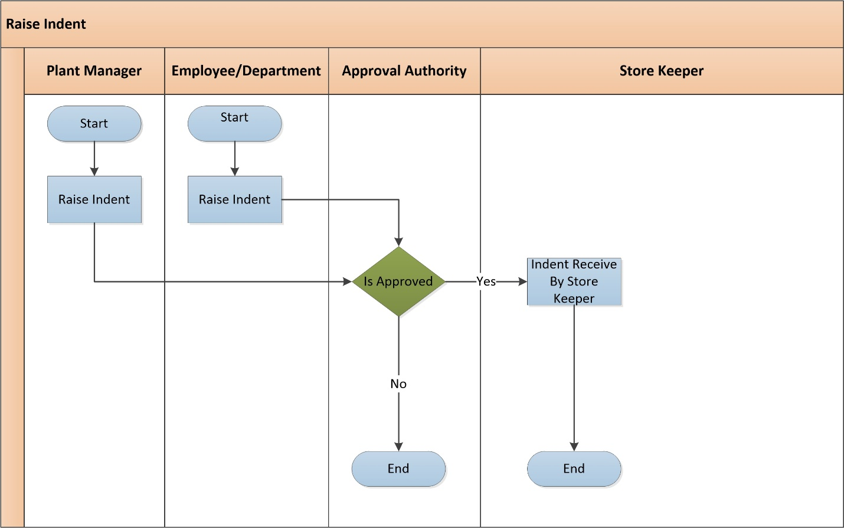

**Fig:** Raise Indent

**Raise Indent Process Description:**

* Plant Manager or Employee/ Department raise indent when they need products for production or Consumption.
* They send the indent to approval authority (plant manager) to approve the indent.
* Approval Authority (plant manager) verifies the indent with necessary information. Depending on the approval decision further process is prepared –
  + **Approved:** If approved, then approval authority sends the approval message to store keeper to take necessary steps.
  + **Not Approved:** If not approved, then approval authority cancels the indent.

## **6.2 Issue Item Process**

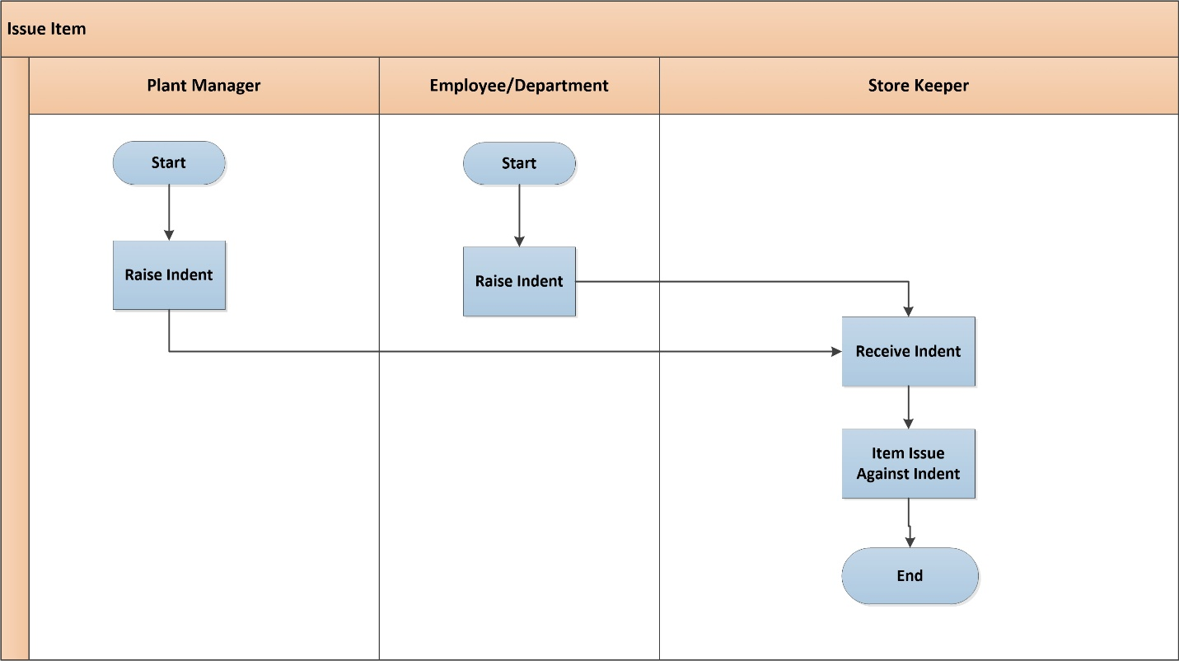

**Fig:** Issue Item Process

**Issue Item Process Description**

* Plant Manager or Employee / Department raises an indent for production or consumption of goods.
* Storekeeper receives indent from plant manager or employee / department.
* Storekeeper issue items to plant manager or employee / department against their raised indent.
* When any item will be issued, the indent will be closed. If there is any pending issue item (e.g. the indent was for 11 pen, but item was issued up to 10 pen), plant manager will have option to close that also.

## **6.3 Issue Return Process**

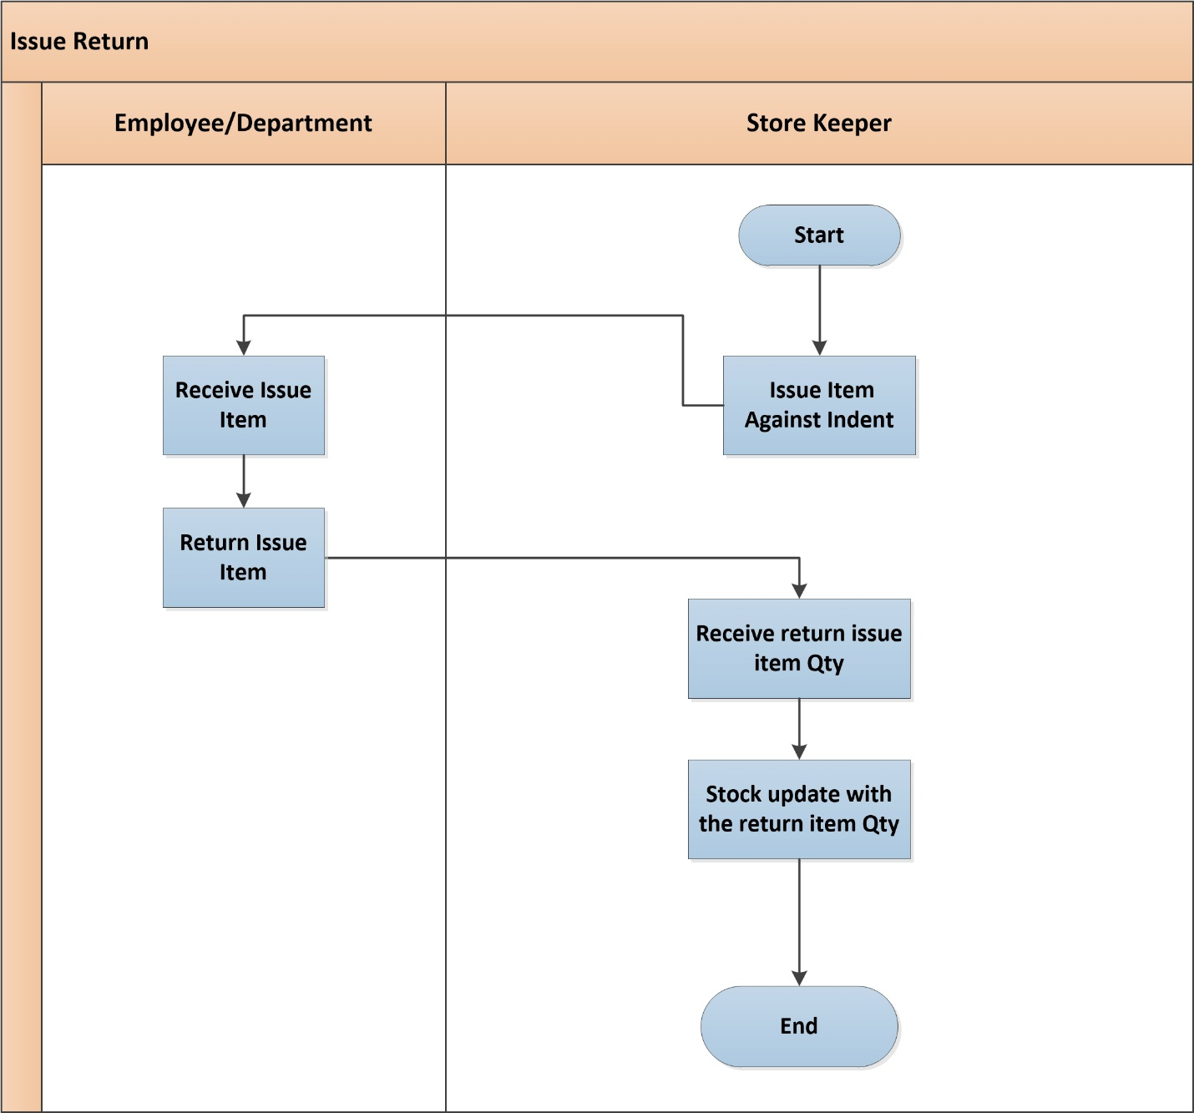

**Fig:** Issue Return Process

**Issue Return Process Description**

* Storekeeper issue item to employee / department against indent.
* Employee / department receive issued item against their indent.
* Employee / Department can return issued item if they are not using all item.
* Storekeeper receives return item from employee / department.
* Storekeeper updates their stock with the return items.

## **6.4 Gate Pass In Process**

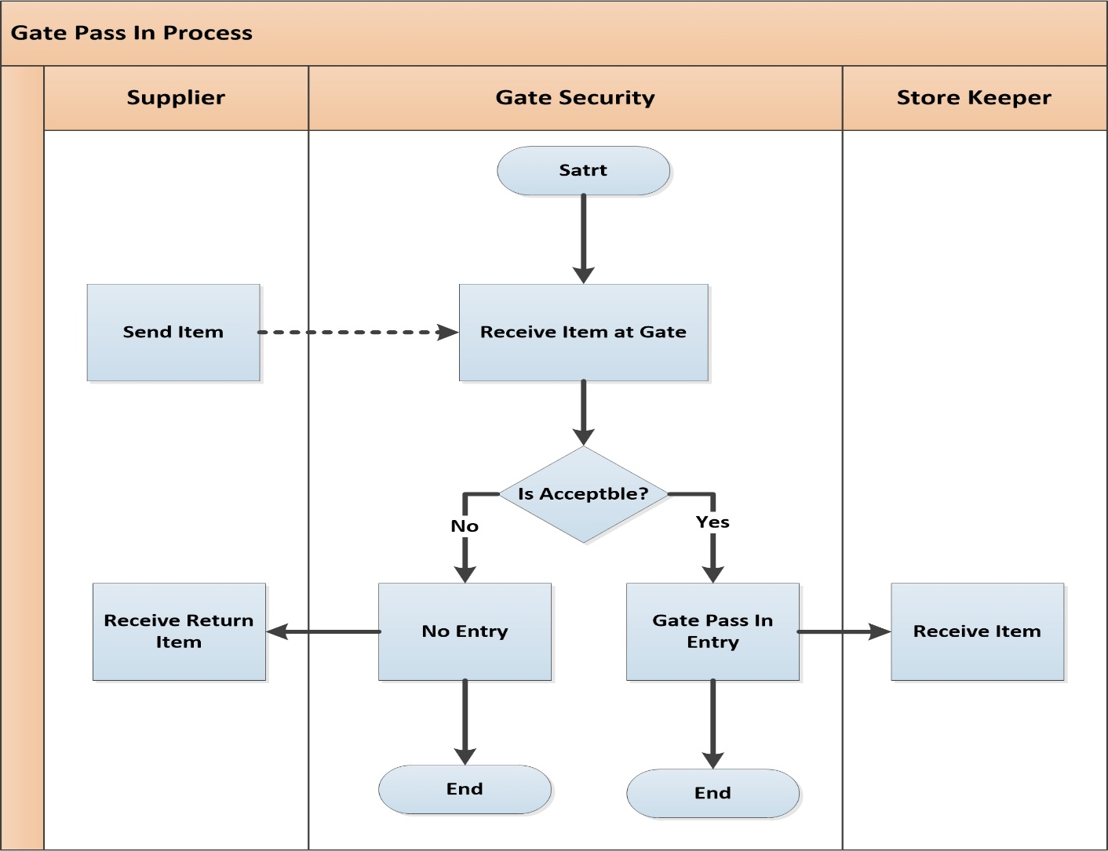

**Fig:** Gate Pass In Process

**Gate Pass In Process Description**

* Supplier sends the item to factory.
* Gate Security checks the item sent by supplier.
* If the items are accepted then gate pass entry will be in the system.
* Storekeeper will receive the items inside the mentioned location.
* If the items are not accepted then items will not get entered in mentioned location and will be sent to supplier again for the correction.

## **6.5 Receive Goods Process**

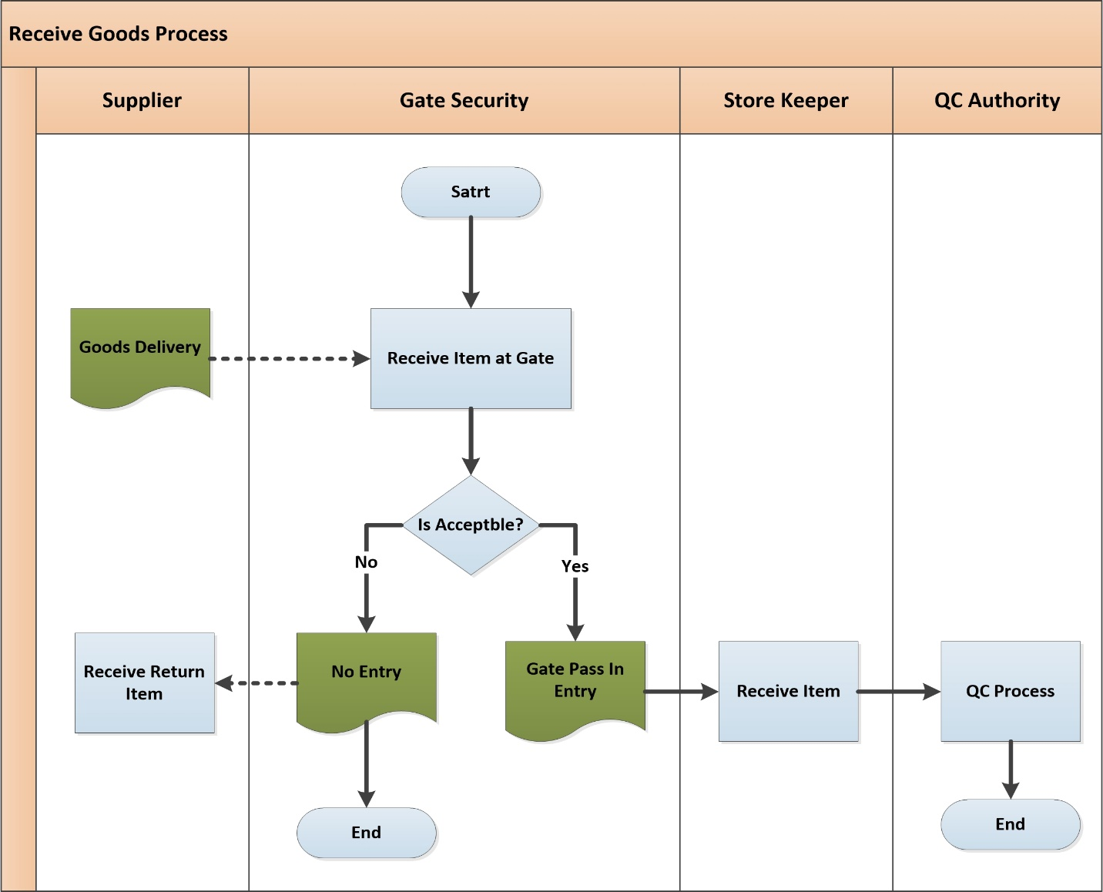

**Fig:** Receive Goods Process

**Receive Goods Process Description**

* Supplier sends goods against Purchase Order (PO) or commercial invoice to requested location. There can have option for loan item also.
* Gate Security checks the item/goods according to instruction.
* If item/goods are not acceptable then it goes back to supplier.
* If item/goods are acceptable then gate pass entry will be in system.
* After that gate security will pass it to Storekeeper.
* Store keeper receives goods from gate security. Store keeper can receive loan items also.
* Store Keeper confirms his acceptance as per Purchase Order (PO) and sends all goods to Quality Control (QC) authority for proper quality control check.
* QC Authority receives goods and the receive goods process ends here.

## **6.6 Receive Return Process**

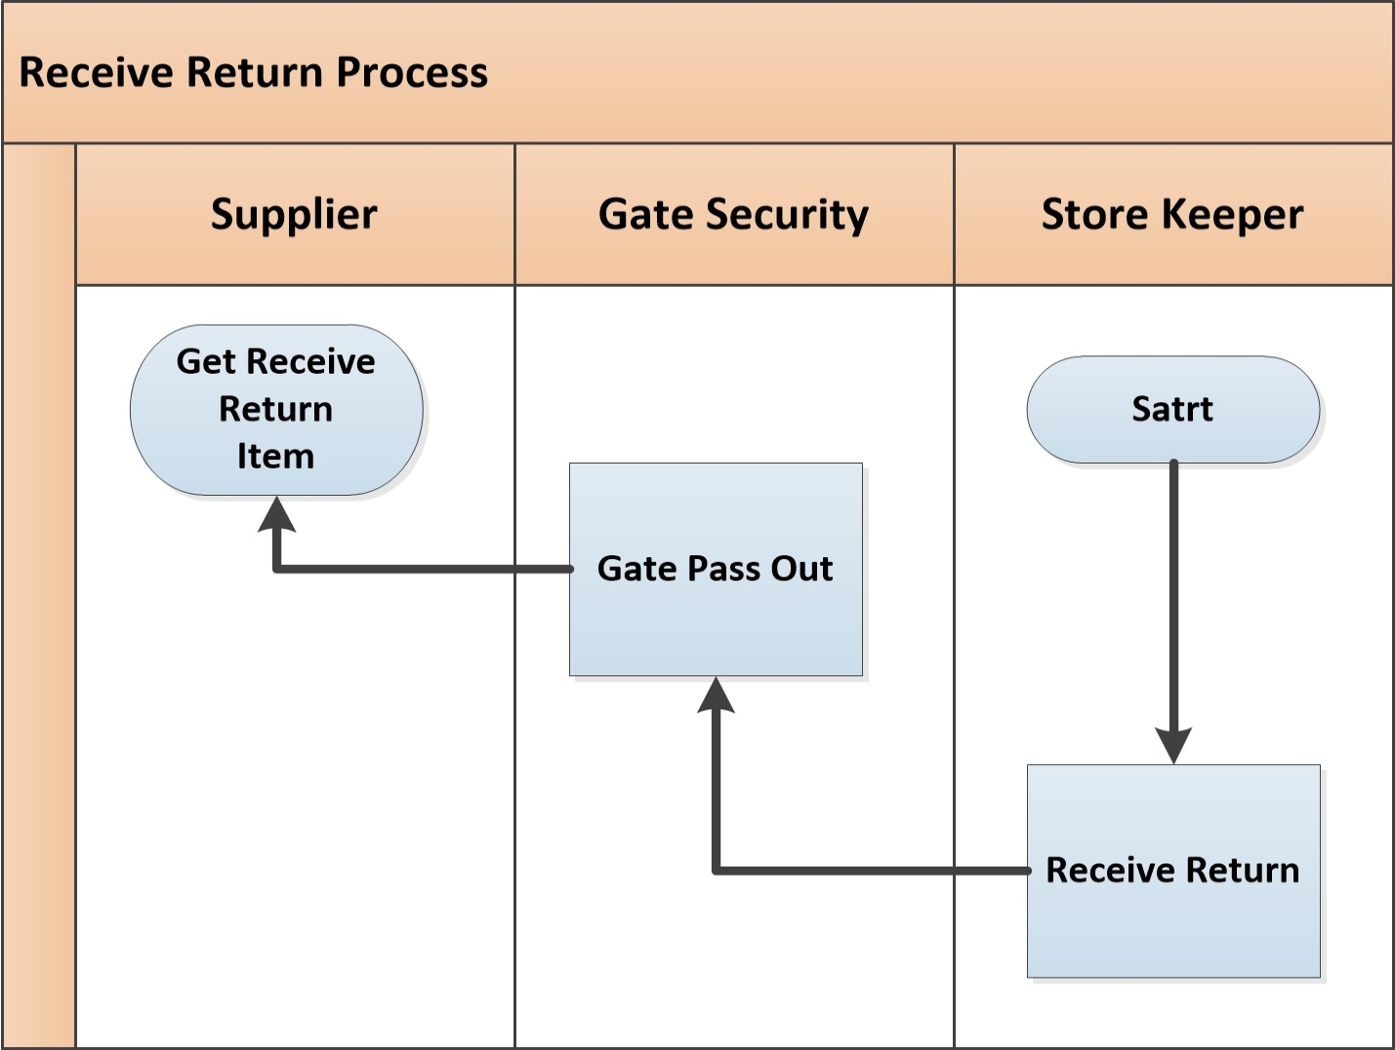

**Fig:** Receive Return Process

**Receive Return Process Description**

* Store Keeper checks all received goods.
* If there is any mismatch in goods against the purchase order then storekeeper sends the goods back to supplier for further action.
* Gate Security gets the request for “gate pass out’ to return goods to Supplier.
* Supplier will receive the returned items.

## **6.7 Quality Control (QC) Process**

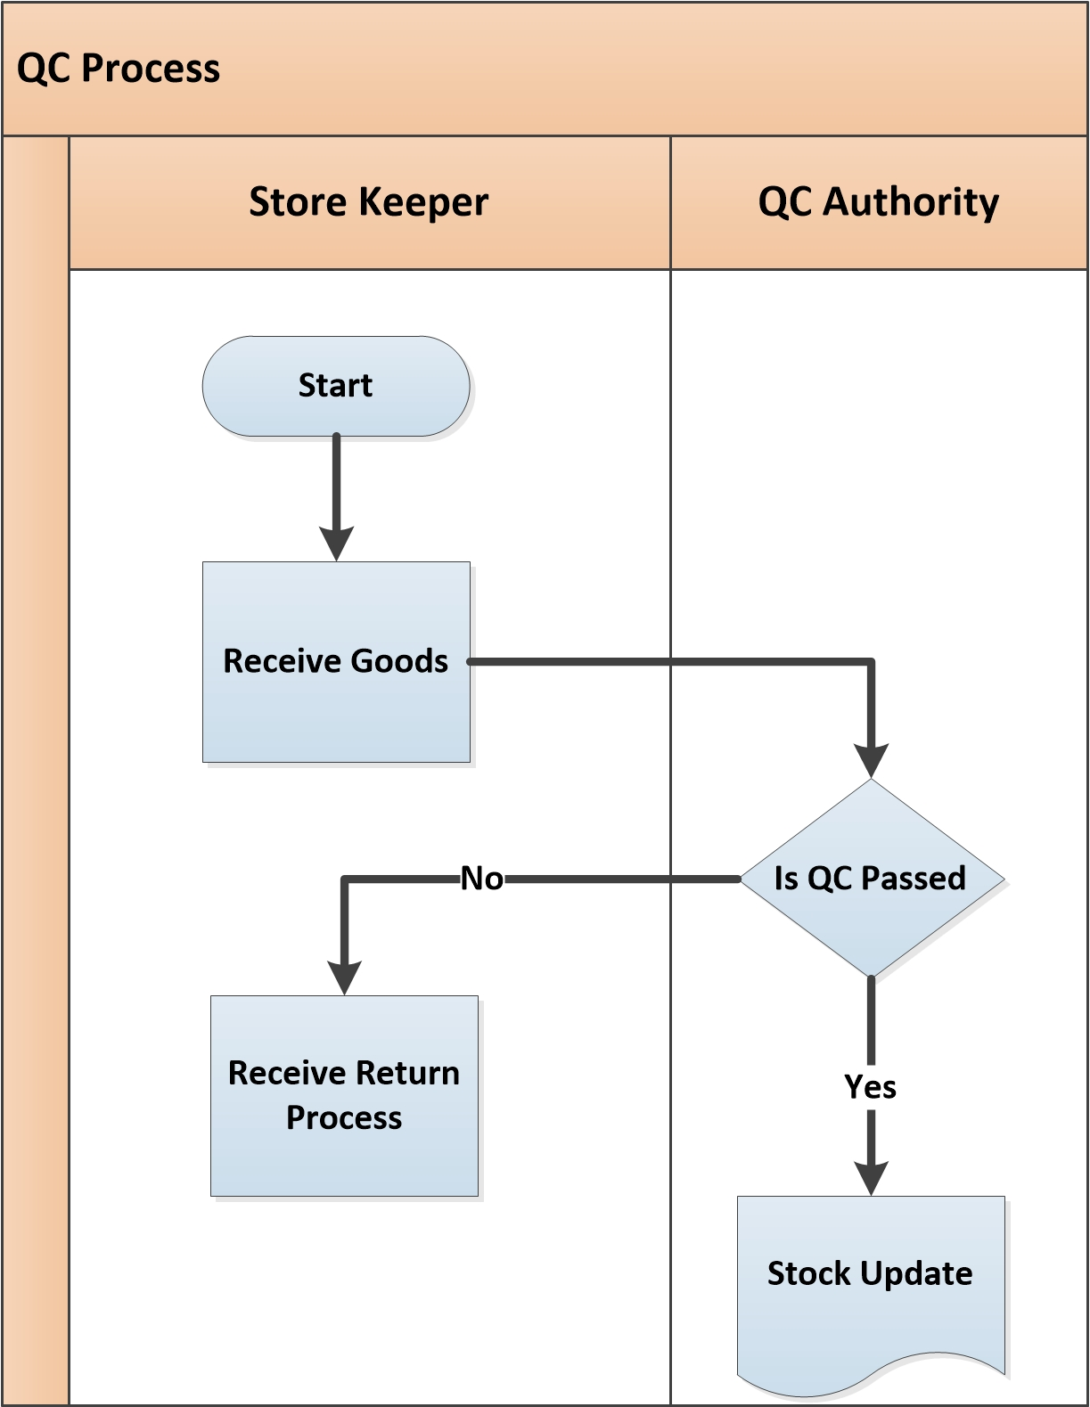

**Fig:** Quality Control (QC) Process

**QC Process Description**

* Gate Security checks the item and pass it to storekeeper.
* Store keeper receives goods which was sent by supplier.
* Store keeper confirms his acceptance as per order and sends all goods to QC authority for proper quality control.
* QC Authority checks the quality and quantity of goods as per Order. According to QC result they take necessary decision-
  + **QC Passed:**
    - If goods are in good quality and exact quantity then QC accept the goods and update the stock of the goods.
  + **QC Failed:**
    - If goods are not acceptable and not in exact quantity/quality, QC authority returns the rejected goods to Store Keeper for receive return to Supplier
* Store Keeper receives all rejected goods which were sent by QC authority and sends the goods back to Supplier for further action.

## **6.8 Material Receive Report (MRR)**

* 1. A material receiving report (MRR) is an internal document used to record what materials and inventory were received by the company. The receiving report is sent to other departments to notify them what items have been received and are ready for use. This form is completed immediately upon receipt of materials, supplies, or services. The person receiving the goods will prepare this report. Industry receives all goods by preparing a Material Receiving Repot (MRR).
  2. In MRR, customer includes all product description with quantity, purchase order no., packing no. and vat if any.
  3. There is MRR approval hierarchy which is given below-

1. Quantity Receive by –> Sign & Designation
2. Received by -> Store Personnel
3. Approved by -> Plant Manager

## **6.9 Goods Delivery Process**

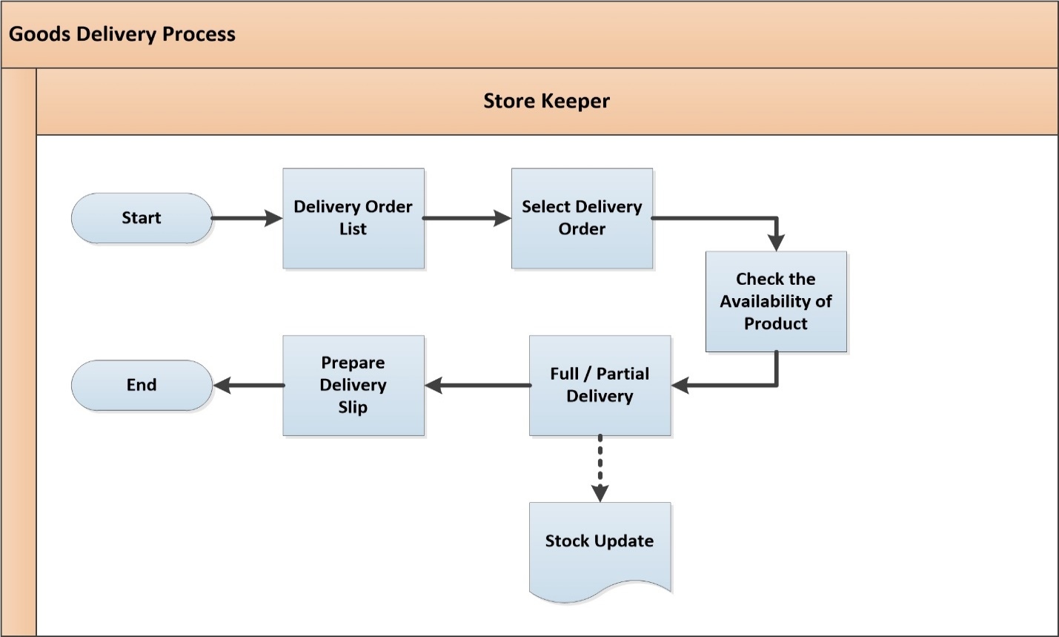

**Fig:** Goods Delivery Process

**Goods Delivery Process Description**

* Store keeper prepares the delivery list including required information and then select the delivery order based on decision. Store keeper can have loan item also for delivery.
* After the selection store keeper checks the availability of product in the store. Based on the order, store keeper starts delivering. Delivery can be partial or full quantity.
* After the delivery store keeper prepares delivery slip.

## **6.10 Gate Pass out Process**

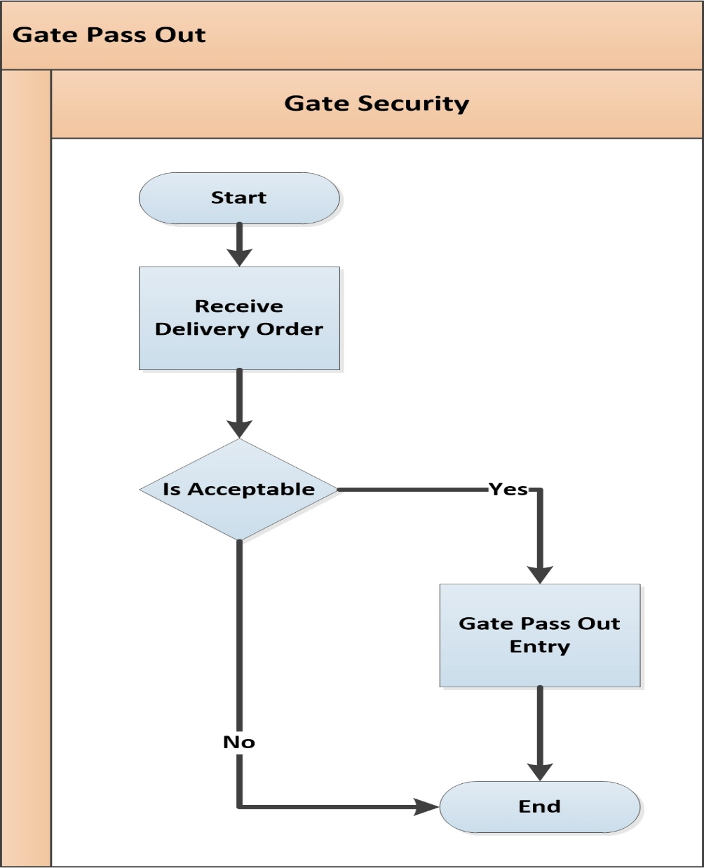

**Fig:** Gate Pass Out

**Gate Pass Out Process Description**

* Gate security receives delivery order from store keeper.
* Store keeper request for gate pass out to send goods/items outside.
* Gate security check the request from store keeper.
* If the request is accepted gate pass out entry will be in system.
* If the request is not accepted the process will end there.

## **6.11 Inventory Item Transfer Process**

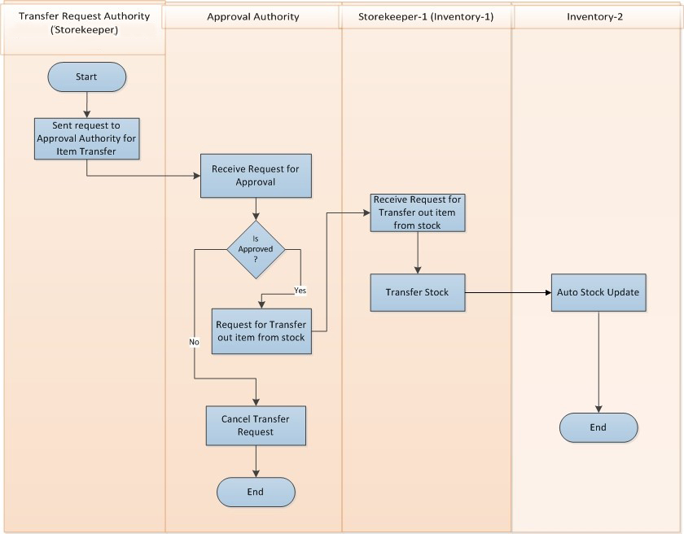

**Fig:** Inventory Item Transfer Process

**Inventory Item Transfer Process Description**

* Transfer request authority send request to approval authority for item transfer.
* Approval authority receives request for approval from transfer request authority.
* If Approval Authority is not approved then cancel the transfer request.
* If Approval Authority is approved then request goes to storekeeper (inventory-1) for transfer out item from stock.
* Storekeeper-1 (inventory-1) receives request from approval authority for transfer out item from stock.
* Storekeeper-1 (inventory-1) transfer the Item Stock from inventory-1 to Invenory-2.
* Stock goes auto updated in Inventory-2.

## **6.12 Physical Inventory Process**

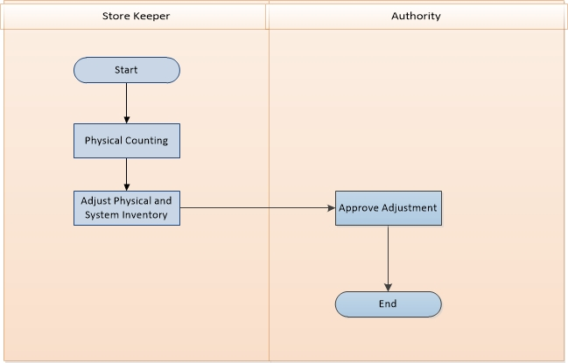

**Fig:** Physical Inventory Process

**Physical Inventory Process Description**

* Storekeeper will count all the item stock physically.
* Storekeeper adjusts the difference in between system and physical stock.
* Authority approves the item adjustment between system and physical stock.

## **6.13 Item Loan Process**

This process usually happens when the company/factory has inadequate items/goods, in that case company/factory can take loan from others. After taking that loan, it will have loan re-payment option for that specific loan. The re-payment can be done by goods or amount wise based on the contract between two parties. There might be another case where another company may take loan from Samuda also. In that scenario, Samuda will receive goods/amount for giving the loan to other company. System will handle the both case mentioned above.

### **a) Item Loan (Lending Process)**

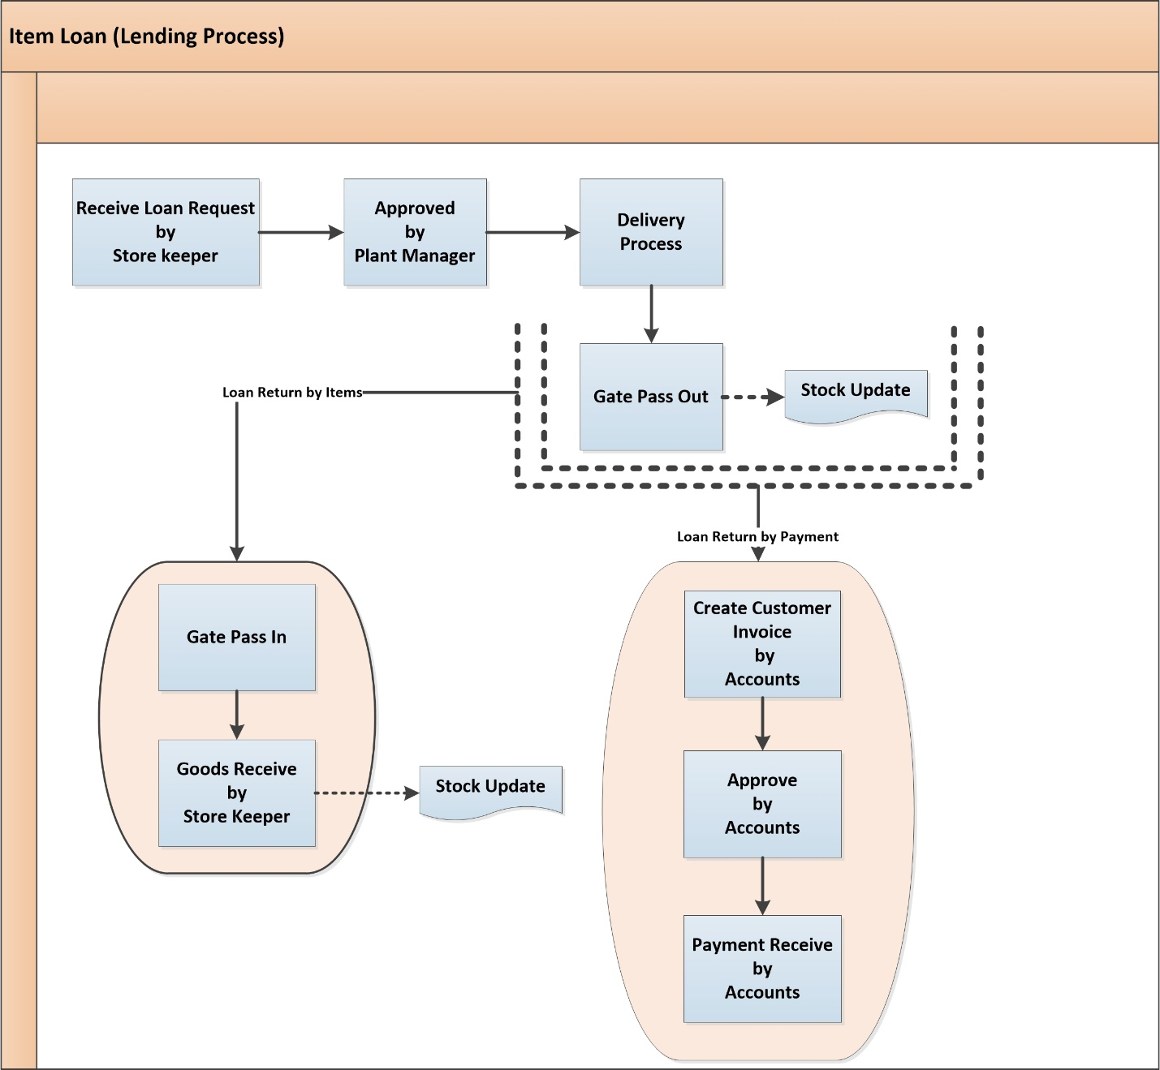

**Fig:** Item Loan (lending) Process

**Item Loan (Lending Process) Description**

* Store keeper will receive loan request for items/goods from other company.
* Plant Manager will approve the loan request.
* Goods will be delivered to the other company in mentioned location and it will have gate pass out process as well. The stock will be update automatically when items are delivered to other company.

1. **Loan Return By Items**

* When other company re-pays the loan by items, it will have gate pass in process
* After that Samuda will have goods receive process for the items they gave loan to others. The stock will be updated automatically.

1. **Loan Return By Payment**

* When other company re-pays the loan by payments, in that case accounts will create customer invoice.
* Approval authority of accounts will approve that.
* The payment from other company will be received by account section.

### **b) Item Loan (Borrowing Process)**

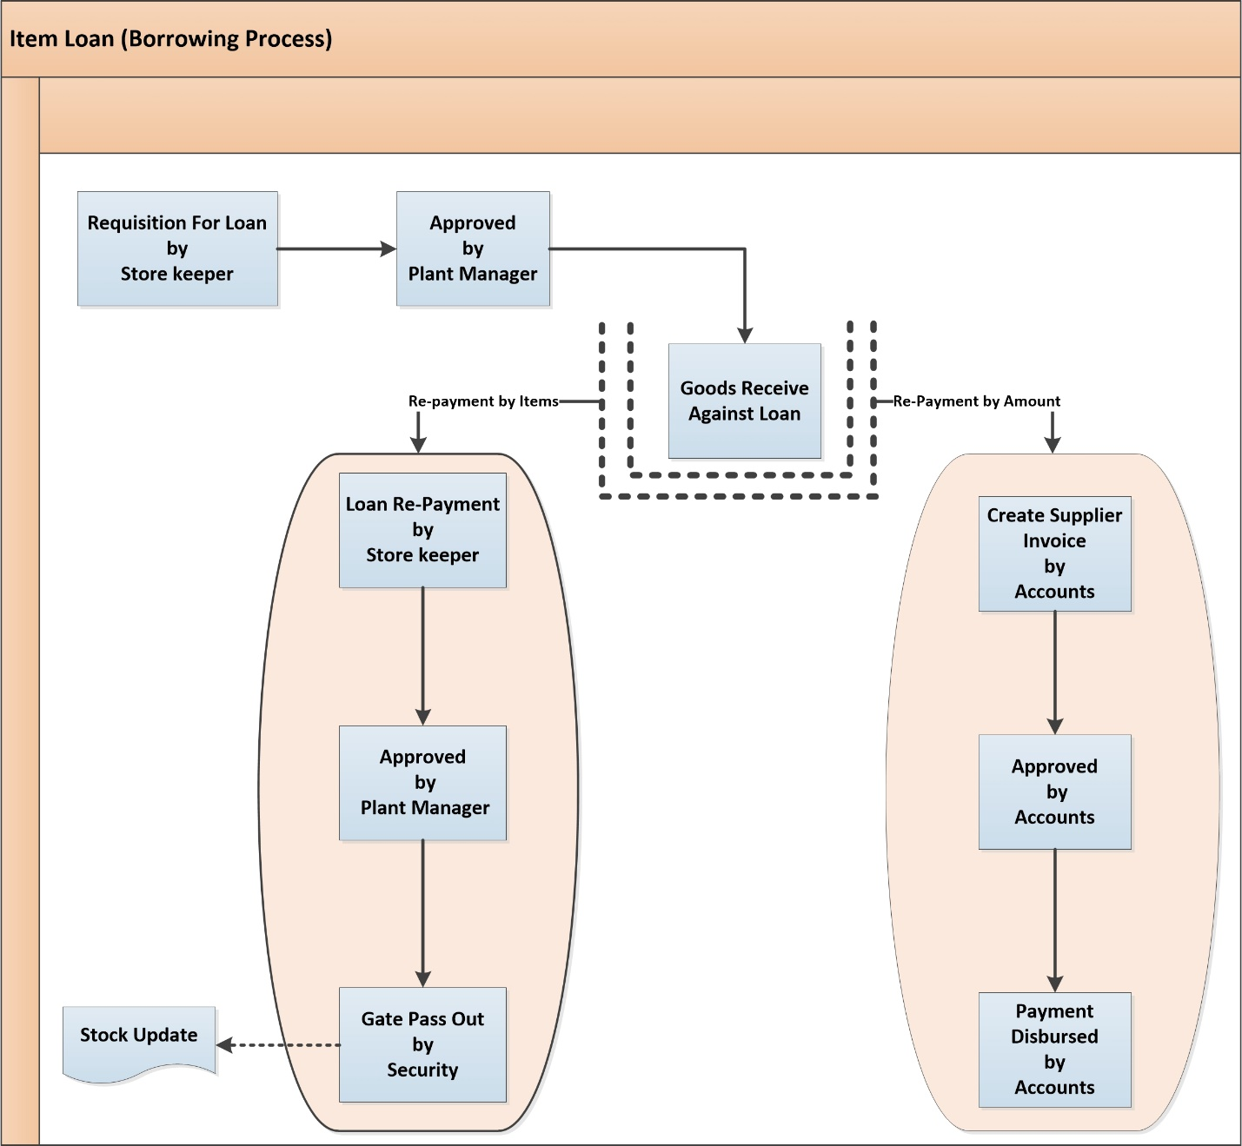

**Fig:** Item loan (Borrowing Process)

**Item Loan (Borrowing Process) Description**

* Store keeper gives requisition for loan items.
* Plant manager will approve the loan request.
* Store keeper will receive goods against the loan.

1. **Loan Re-Payment By Items**

* When loan re-payment is done by items, it will be done store keeper, approved by plant manager.
* Store keeper will have gate pass out request and then items will be re-paid to the other company.
* Stock will be updated automatically.

1. **Loan Re-Payment By Amount**

* Store keeper will create supplier invoice for the loan re-payment.
* It will be approved by accounts section.
* Payment disbursed will be done by accounts.

# **7. Appendix**

Some Forms of Samuda maintain for its inventory system.

1. Sales Order

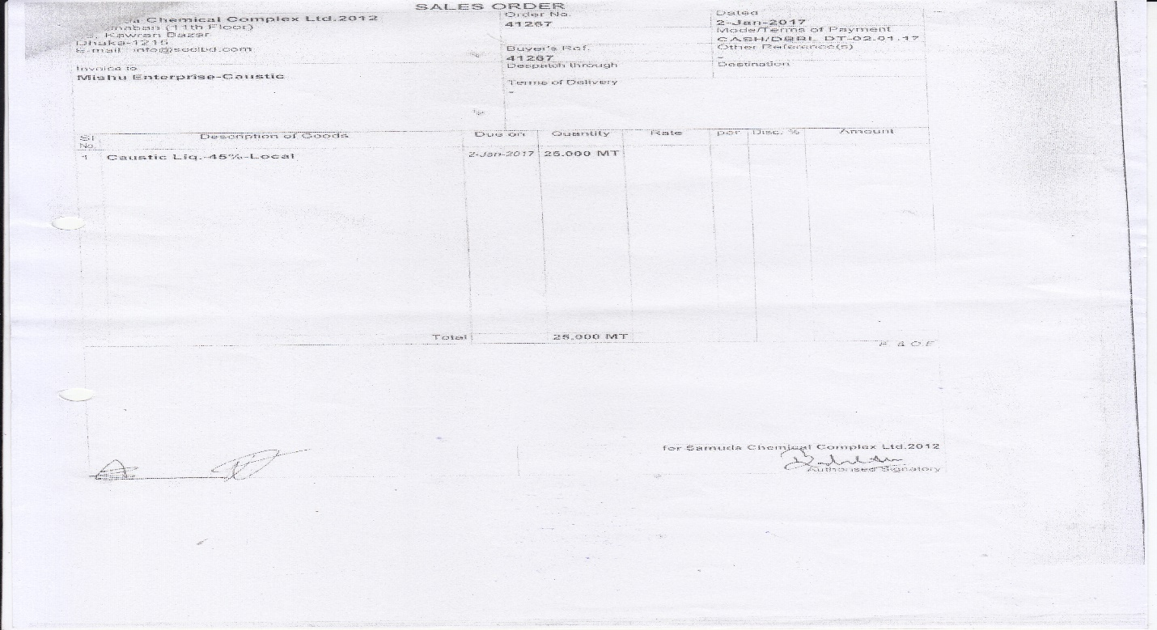

1. Delivery Slip

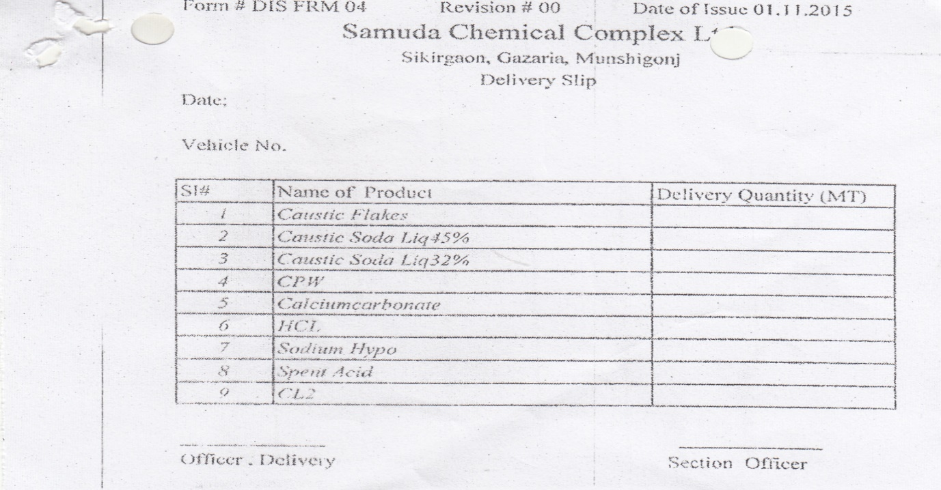

3. Purchase Requisition (PR)

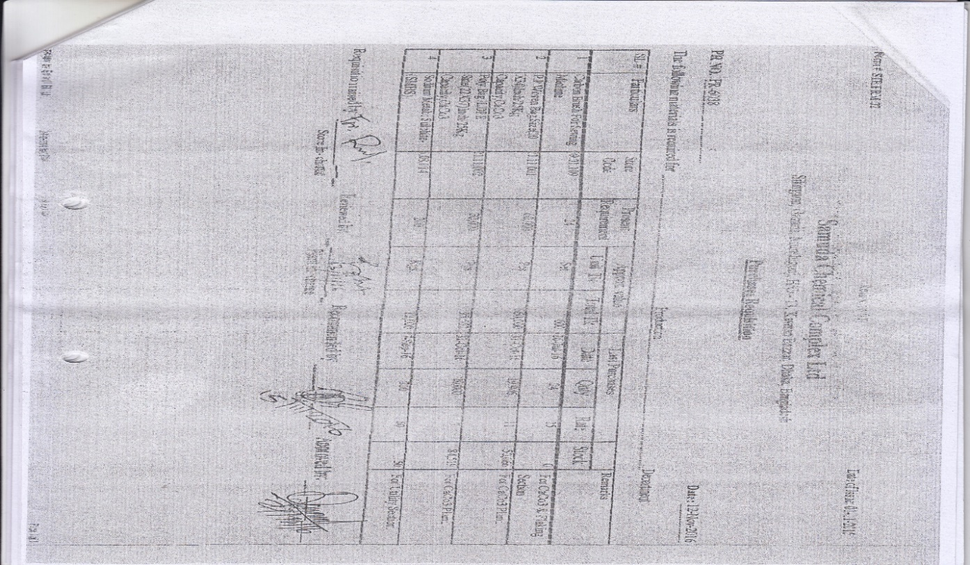

4. Purchase Order (PO)

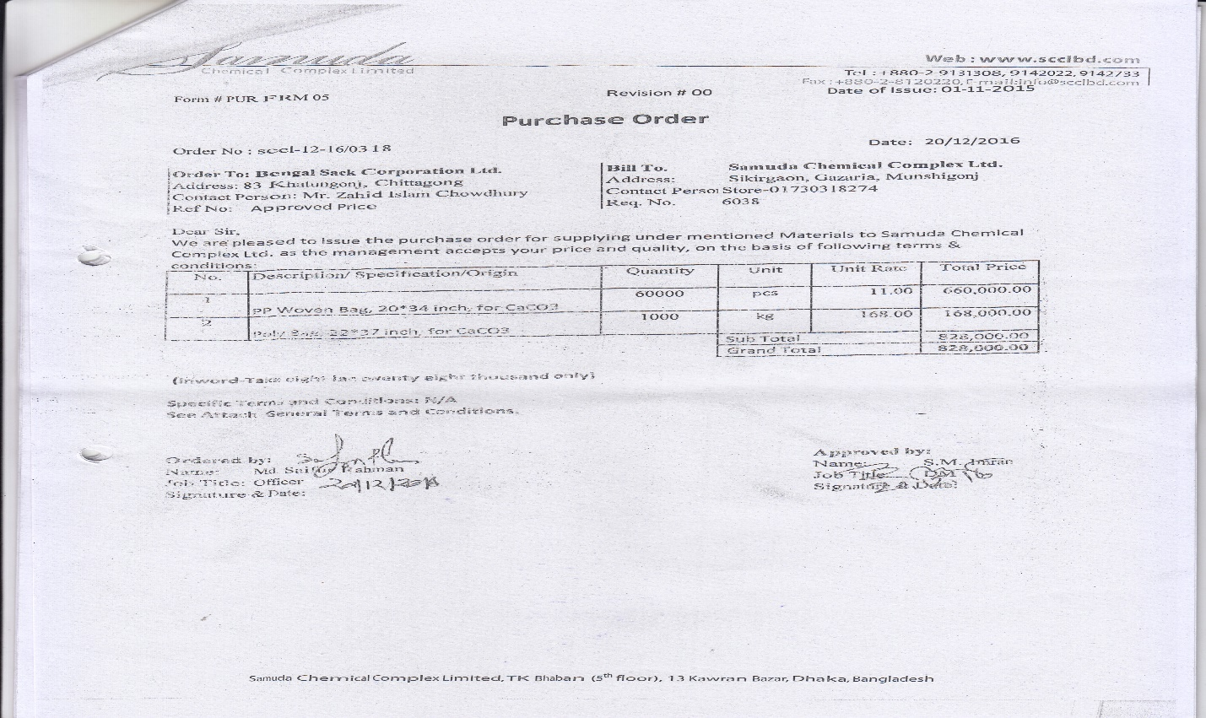

1. Supplier’s Delivery Challan

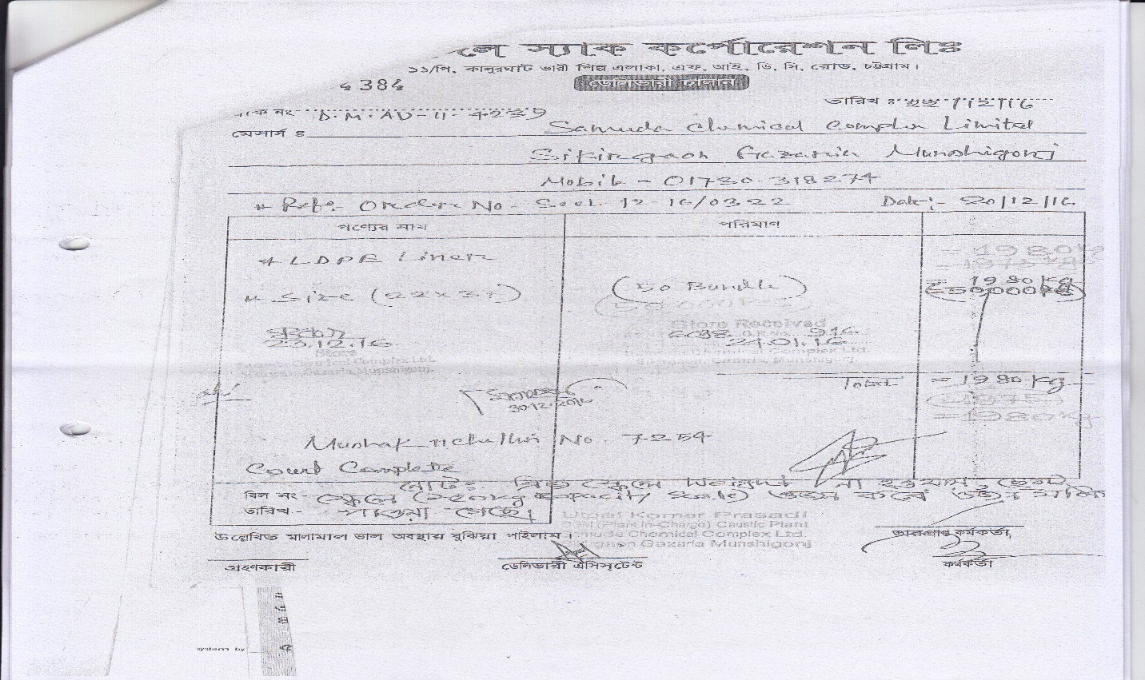

6. Challan Letter

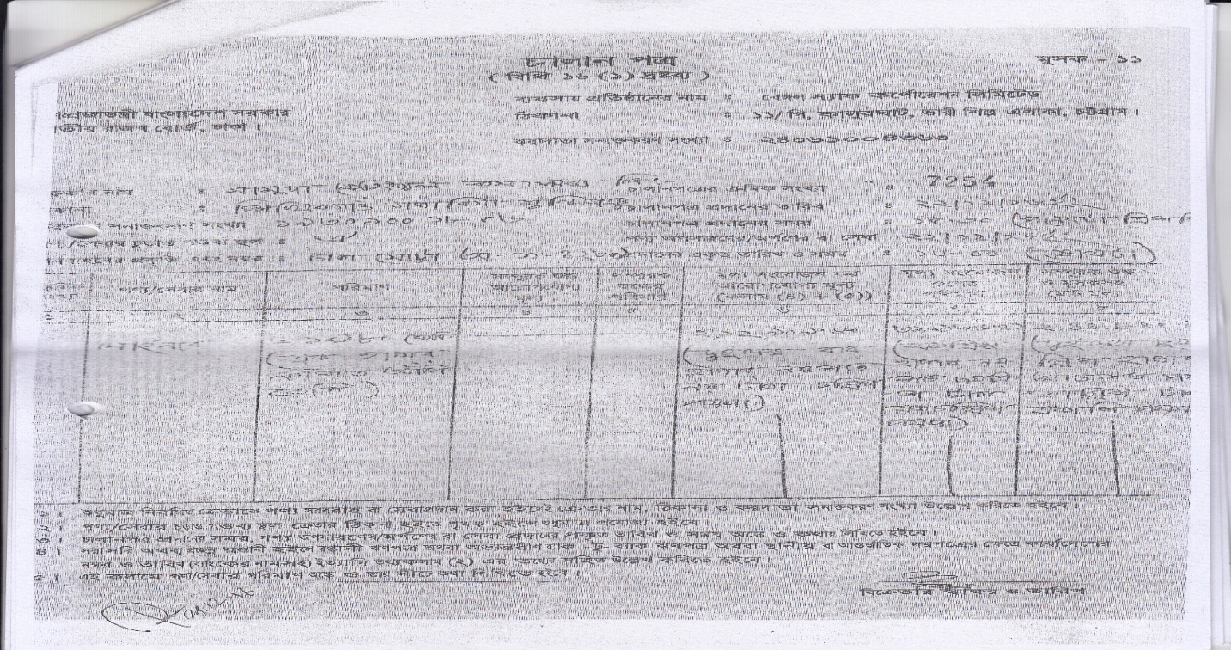

7. Quality Certificate

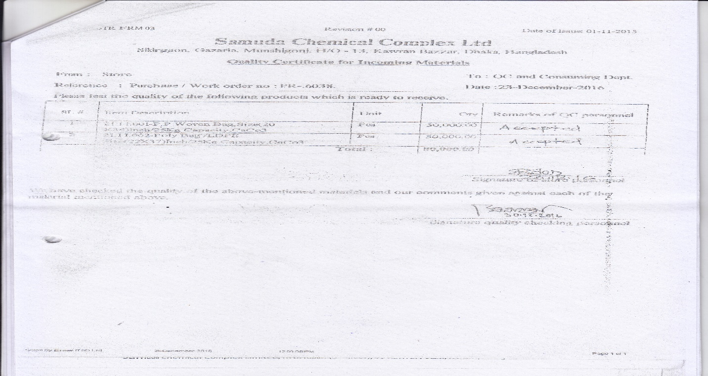

8. Material Receiving Report (MRR)

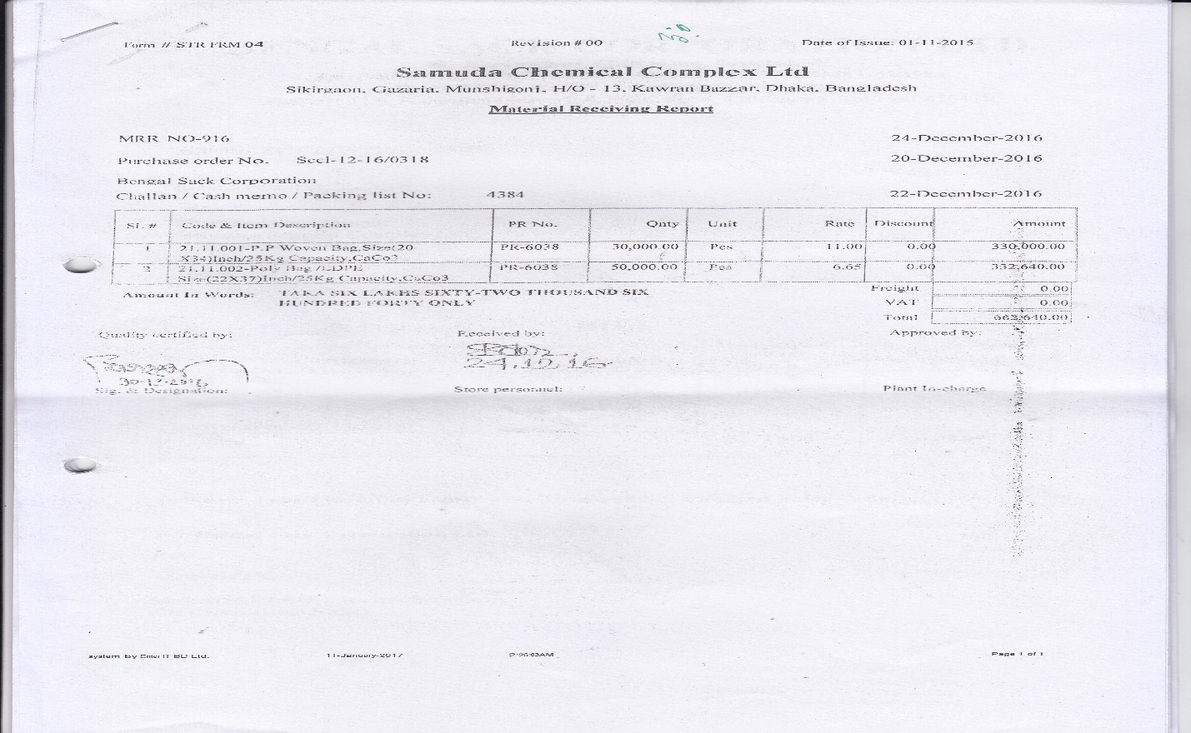

9. Bill

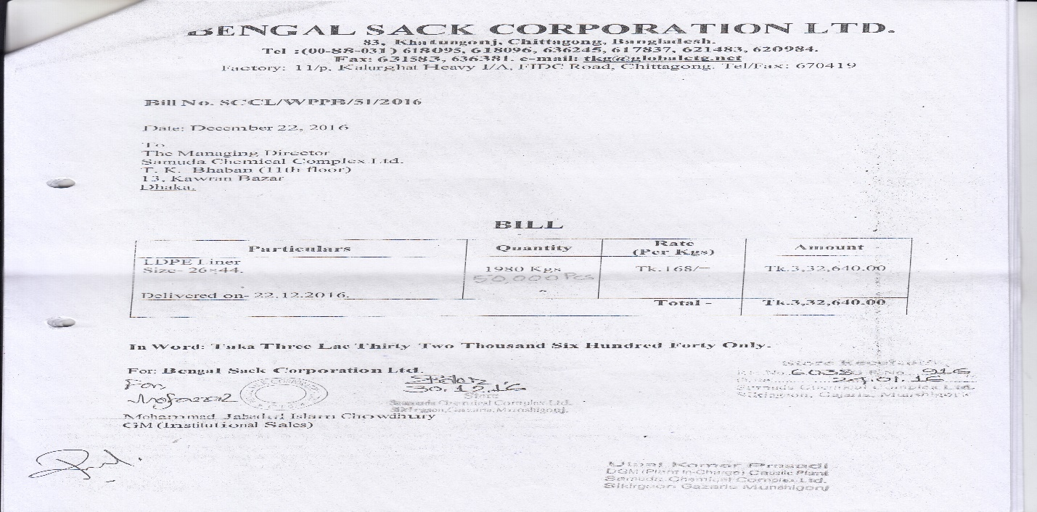

# **8. To be Determined**

1. ISO 9001 related reports are not implemented within this phase. We will cover in next phase.

Signed on behalf of Signed on behalf of

Samuda Chemicals Ltd. Genweb2 Limited

Name: Name:

Designation: Designation:

Date: Date:

**______________________________ ______________________________**

Signature Signature